**LEBANESE AMERICAN UNIVERSITY**

**USAID – HIGHER EDUCATION SCHOLARSHIP PROGRAM**

**HES - Volunteering Program Verification Form**

This form is to be used to document volunteering hours. If a student volunteers for multiple organizations, a separate form must be used for each organization. **This form must be turned in by the 28th of each month, the latest.**

I certify that the scholar Jana Al Banna completed a total of 20 hours of service at InnovaThrive.

The hours were completed hours as per the below:

Hours # 4 (date) _2/12 – 6/12_ (initials of supervisor) __A.K.___

Hours # 4 (date) _9/12 – 13/12_ (initials of supervisor) __A.K.___

Hours # 4 date) _16/12 – 20/12 (initials of supervisor) __A.K.___

Hours # 4 date) _23/12 - 27/12 (initials of supervisor) __A.K.___

Brief description of the activities the scholar performed or participated in:

Jana, as the graphic design manager at the NGO Innovathrive, plays a crucial role in creating visual content for the organization's social media presence. She assigns design projects to volunteers who contribute by creating graphics, posters, and other visual materials to promote the NGO's initiatives and events. Jana ensures that the content reflects the NGO’s mission, values, and branding, while also conveying the intended messages clearly and effectively. She collaborates closely with the volunteers, providing guidance, support, and feedback to maintain high-quality work. Her efforts help Innovathrive raise awareness, engage with the community, and effectively communicate its social impact and objectives.

Written feedback about the scholar’s performance:

Jana exhibited excellent leadership, organizational, and creative skills by managing design projects and ensuring high-quality visual content that aligns with the NGO’s mission.

Please rate the overall performance of the scholar at your organization:

|  |  |  |  |
| --- | --- | --- | --- |
|  | Mastery (5) | Proficient (3) | Emerging (1) |
| **Problem solver** | X |  |  |
| **Engaged & Committed** | X |  |  |
| **Open-minded & multicultural** | X |  |  |

Signature

& stamp

__________________________

_

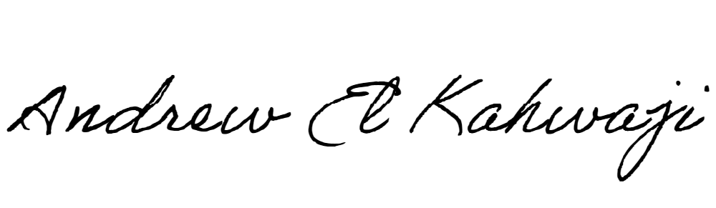

Printed Name _Andrew El Kahwaji_

Date __26/12/2024___

Email __andrew.lifesculptor.coo@gmail.com __

Phone __+961 71 914 378__